<https://jaypeeonline.net/tips-tricks/requires-installation-of-untrusted-packages-error/>

One of the first things I did after I got my [Lenovo IdeaPad Y560](https://jaypeeonline.net/gadgets/lenovo-ideapad-y560/) was to make it dual boot to Windows 7 and [Ubuntu](https://jaypeeonline.net/category/ubuntu/). After I have installed Ubuntu, I immediately run the **Update Manager** to update the system. Btw, I always update the system (either **Windows** or **Ubuntu**) before I install any programs or do any customizations. This makes sure that all components are up-to-date and helps make the system run smoother and lessens the chances of errors or conflicts with other components.

Anyways, when I tried to download and install the available updates for Ubuntu, I got this error message:

*Requires installation of untrusted packages – “The action would require the installation of packages from not authenticated sources.”*

I’ve installed Ubuntu lots of times before and this was the first time that I encountered this issue/error. I Googled the error message and found the very short and very simple solution from the **Ubuntu forums**. I’m sharing this in case someone might encounter the same problem and get the “**requires installation of untrusted packages**” error while updating Ubuntu.

Here’s how to do it:  
1. On your Ubuntu panel, click on **System > Administration > Update Manager**.  
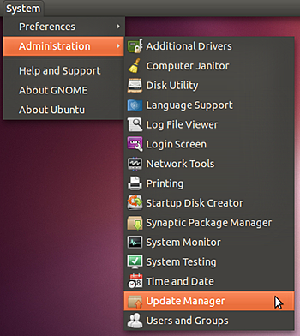

2. Look for **Settings** at the bottom left corner of the **Update Manager** window, click on it.  
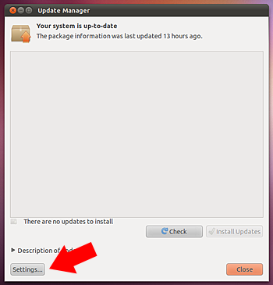

3. On the **Software Sources** window, click on the **Ubuntu Software** tab.  
4. Under **Downloadable from the Internet**, put a check on **Source Code**.  
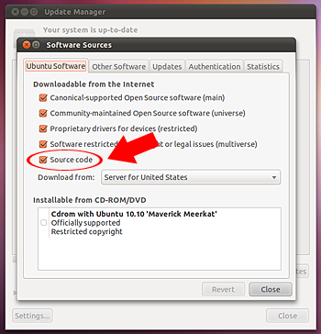

5. **Close** the window and the changes will be applied.  
6. On Update Manager, click on **Install Updates**.

**UPDATE:**  
As mentioned in one of the comments by Sky WalkeR, this issue can also be fixed by typing in the following command lines in the terminal:



|  |  |
| --- | --- |
| 1  2 | sudo apt-get update  sudo apt-get upgrade |

That should do it and you should now be able to download and install the available updates for your system. In my case, the **Source Code** option was not ticked/checked. After I put a check on it and clicked on **Install Updates**, the “**requires installation of untrusted packages**” error went away.

Hope this short and simple tutorial will help you if you encounter the same problem while updating **Ubuntu**. If you know of a different way to solve this problem when updating Ubuntu, please feel free to share it with us via the comment section. Thank you!